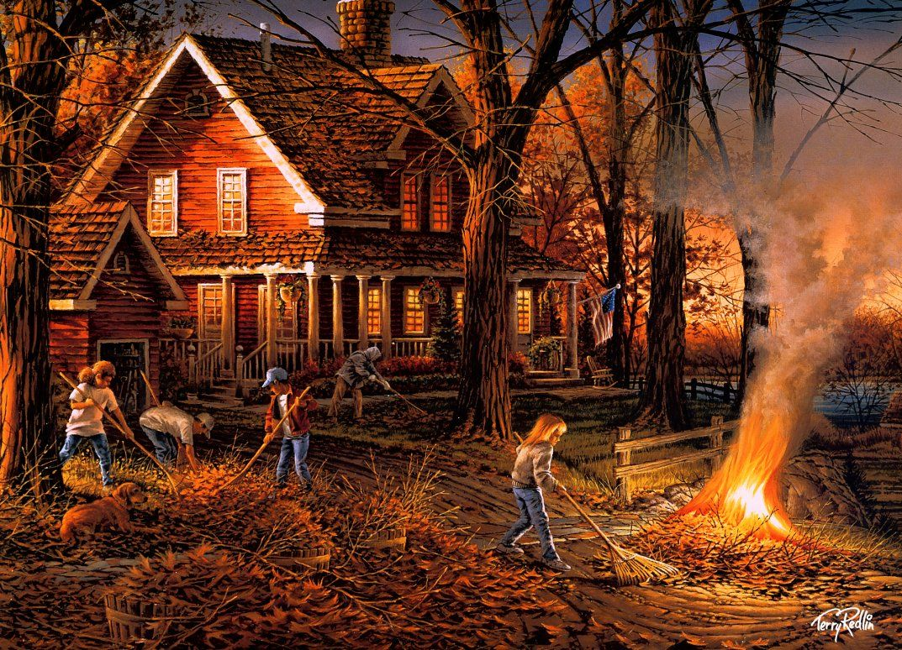

November 2019 Events

|  |  |  |  |  |  |  |
| --- | --- | --- | --- | --- | --- | --- |
| SUNDAY MONDAY TUESDAY WEDNESDAY THURSDAY FRIDAY SATURDAY |  |  |  | Image result for Volleyball ClipartImage result for Volleyball ClipartImage result for Volleyball Clipart | 1  YOUTH CONVENTION | 2  Women’s Bible 10AM  Prayer 5-6 PM |
| 3  **Communion**  Bible 9  Prayer 9:15  Service 10 | 4  Spanish GED  6 PM | 5 | 6  Bible Study  7 – 8:30 PM | 7  Volleyball 7 PM  C:\Program Files (x86)\Microsoft Office\MEDIA\CAGCAT10\j0301480.wmf | 8  Corporate Prayer 7 PM  FAIR HAVEN | 9  Senior Trip  Frankenmuth  9:00 AM  Prayer 5-6 PM |
| 10   Bible 9 AM  Prayer 9:15  Service 10 AM | 11  Spanish GED  6 PM | 12 | 13  Bible Study  7 – 8:30 PM | 14  Volleyball 7 PM  C:\Program Files (x86)\Microsoft Office\MEDIA\CAGCAT10\j0301480.wmf | 15 | 16  Men’s Breakfast 9-10:30 AM  Women’s Bible 10-Noon  Hour of Power 5 |
| 17  **SHOEBOX RETURN**  Bible 9 AM  Prayer 9:15  Service 10 AM | 18  Spanish GED  6 PM | 19 | 20  Bible Study  7 – 8:30 PM | 21  **BOXES OF LOVE PACKING 5:30-8:30**  cardboard box.png  Volleyball 7 PM | 22 | 23 Fuel For Leadership 10AM  **BOXES OF LOVE DISTRIBUTION**  **12-2:30 PM**  Prayer 5-6 PM  Fuel For Leadership 10-Noon  Prayer 5-6 PM  **forLeader**  **ship** |
| 24  Bible 9 AM  Prayer 9:15  Service 10 AM | 25  Spanish GED  6 PM | 26 | 27  **NO CLASSES** | 28  turkey clipart copy.jpg  Image result for pumpkin transparent background | 29 | 30  **NO PRAYER** |